

DATABASE

SPECIFICATIONS

Next-Gen Restaurant Application
Venkat Nihaal Akula
vxa5088@psu.edu

School of Graduate Professional Studies
Information Science Department
IN SC 521 - Introduction to Database Concepts

September,2019

Document Control

Work carried out by:
Name | Email Address | Other
Venkat Nihaal Akula | Vxa5088@psu.edu | (484)725-1528

Revision Sheet

Release No. | Date | Revision Description
1 | 09|08|2019 | Database Requirements Gathering
2 | 09|14|2019 | Conceptual Design
3 | 09|22|2019 | Logical Design
4 | 09|29|2019 | Normalization
5 | 10|06|2019 | Physical Design
6 | 13|06|2019 | SQL Queries

DATABASE SPECIFICATIONS

TABLE OF CONTENTS

Document Control i
Work carried out by: i
Revision Sheet i
Milestone 1: Data Requirements 1
Purpose 1
Outcomes 1
Student contribution 1
System Name or Title 1
Core requirements 1
Milestone 2: Conceptual Design 2
Purpose 2
Outcomes 2
Student contribution 2
Entity Relationship Diagram 2
Assumptions and Constraints 3
Milestone 3: Logical Design 4
Purpose 4
Outcomes 4
Student contribution 4
Entity Relationship Diagram 4
Assumptions and Constraints 5
Milestone 4: Normalization and 6
Milestone 5: Physical Design 6
Purpose 6
Outcomes 6
Student contribution 6
Assumptions and Constraints 6
Naming Conventions 6
Tables 6
Examples of values 6
Notes 6
Milestone 6: SQL queries and 8
Purpose 8
Outcomes 8
Student contribution 8

Milestone 1: Data Requirements

System Name or Title
Next-Gen Restaurant Application

Core requirements

No. | Requirement | Referenced page in SRS | Referenced Section in SRS | Referenced Paragraph in Sez`ction
1 | Database should have administrator details for logging in and then for creating and making changes to the digital table map of the restaurant. | 3  10 | 1.2  3.5.2 | 1.2 (1)  3.5.2
2 | Customer details with type of customers (walk-in customers & customers with reservations), date of arrival must be stored in the database, so that consumer volumes and high/low traffic periods can be calculated. | 3  4  5 | 1.2  1.2  2.2 | 1.2(3)  1.2(9)  2.2(9)
3 | Tables details with a flag that says (vacant or occupied) should be recorded in the database for knowing the availability of the table. | 3 | 1.2 | 1.2(3)
4 | Food Order details containing date, Items, price must be stored in the database for calculating sales tax and then creating a final order (point-of-sales), which should also consists details regarding gratuity paid to the server and these details can be used for maintaining order history, order status and the table to which order has to be sent must be stored for the kitchen staff to handle the order. | 3  3  8  9  9  9 | 1.2  1.2  2.4  3.5.1  3.5.1  3.5 | 1.2(4)  1.2(6)  1  3.5.1.5  3.5.1.2  3.5.1.3
5 | Staff Details containing their designations (Executive Team, Restaurant Management, Servers, Hosts/Hostesses, Kitchen Staff, Restaurant Management, Customer) and their work schedules must be stored in the database for optimizing staff scheduling and also the date of birth of the staff has to be provided for restraining them from serving alcohol if the age is below 21. | 6  3  8 | 2.3  1.2  3.1 | 2.3(3)  1.2(7)  3.1.2
6 | Menu Item details should be stored with relationship to the orders placed, so that item consumption details can be calculated. | 4 | 1.2 | 1.2(9)
7 | Receipt details must be stored from orders (combining both food order and bar order) must be stored in the database. | 5 | 2.2 | 2.2(4)

8 | Bar Order details must be stored in database with prices to maintain tabs for the bar orders and to request manager’s authorize for bills exceeding 300$. The final bill details can be used for calculating sales tax and then creating a final order (point-of-sales). | 10  10 | 3.5.1  3.5.1 | 3.5.1.10  3.5.1.12
9 | Wait Queue details should be stored in the database to keep track of customers name, party size and mobile numbers for notifying customer or host when required. | 3  10  11 | 1.2  3.5.3  3.5.3 | 1.2(2)  3.5.3  3.5.3
10 | Reservation Management should take place by maintaining details regarding every reservation made with reference to the customer details, party size of the reservation. | 12 | 3.5.6 | 3.5.6

Milestone 2: Conceptual Design

Diagram
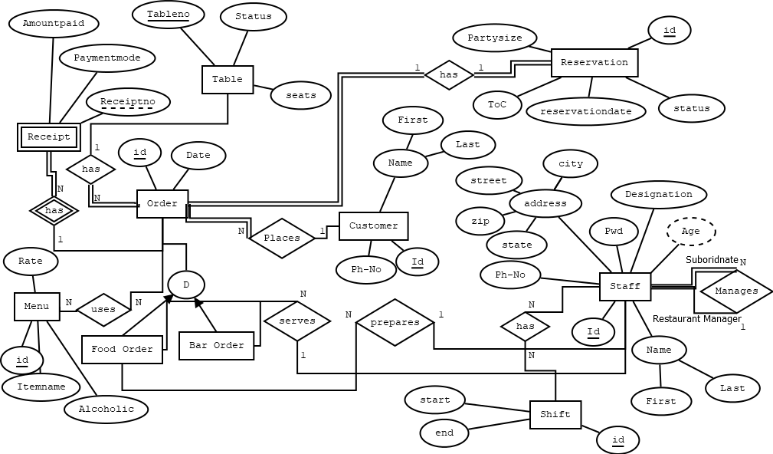

Assumptions and Constraints
- Bar Order does not require preparation, they can be served directly by the servers.
- A final order bill will be generated by combining food order value and bar order value.
- Server identifies the destination of Food order and Bar order by the table no to which it must be served.
- ToC for Reservation means Type of Customer (Reserved/walk-in).

Milestone 3: Logical Design

Entity name: Order
Attributes: Id, Date.
Keys: Id
Functional dependencies:
Id → Date.
Attributes not in FD | Attributes on the left | Attributes on both sides | Attributes on the right side
- | Id | - | Date

Attribute closures (if any):
{Id}⁺ → {Id, Date}
Unique keys: the key for this table is Id.

Entity name: Customer
Attributes: Id, Firstname, Lastname, Ph-No.
Keys: Id
Functional dependencies:
Id → First Name, Last Name, Ph-No.
Attributes not in FD | Attributes on the left | Attributes on both sides | Attributes on the right side
- | Id | - | Firstname, Lastname, Ph-No

Attribute closures (if any):
{Id}⁺ → {Id, Firstname, Lastname, Ph-No }
Unique keys: the key for this table is Id.

Entity name: Staff
Attributes: Id, Firstname, Lastname, Ph-No, Managerid, Street, City, State, Zip, Designation, Pwd, DoB.
Keys: Id
Functional dependencies:
Id → First Name, Last Name, Managerid, Ph-No, Street, City, State, Zip, Designation, DoB, Pwd.
Attributes not in FD | Attributes on the left | Attributes on both sides | Attributes on the right side
- | Id |  | First Name, Last Name, Ph-No, Street, City, Managerid, State, Zip, DoB, Designation, Pwd

Attribute closures (if any):
{Id}⁺ → {Id, First Name, Last Name, Managerid, Ph-No, Street, City, State, Zip, Designation, DoB,Pwd}
Unique keys: the key for this table is Id.

Entity name: Reservation
Attributes: Reserve-id, Reservationdate, Status, ToC, Partysize.
Keys: Reserve-id
Functional dependencies:
Reserve-id → Reservationdate, Status, ToC, Partysize.
Attributes not in FD | Attributes on the left | Attributes on both sides | Attributes on the right side
- | Reserve-id | - | Reservationdate, ToC, Status, Partysize

Attribute closures (if any):
{Reserve-id}⁺ → {Reserve-id, Reservationdate, Status, ToC, Partysize}
Unique keys: the key for this table is Reserve-id.

Entity name: Table
Attributes: Tableno, Status, Seats.
Keys: Tableno
Functional dependencies:
Tableno → Status, Seats.
Attributes not in FD | Attributes on the left | Attributes on both sides | Attributes on the right side
- | Tableno | - | Status, Seats.

Attribute closures (if any):
{Tableno}⁺ → {Tableno, Status, Seats}
Unique keys: the key for this table is Tableno.

Entity name: Receipt
Attributes: Receiptno, Paymentmode, Amountpaid
Keys: Receiptno
Functional dependencies:
Receiptno → Paymentmode, Amountpaid.
Attributes not in FD | Attributes on the left | Attributes on both sides | Attributes on the right side
- | Receiptno | - | Paymentmode, Amountpaid

Attribute closures (if any):
{Receiptno}⁺ → {Receiptno, Paymentmode, Amountpaid}
Unique keys: the key for this table is Receiptno.

Entity name: Menu
Attributes: Id, Itemname, Alcoholic, Rate.
Keys: Id
Functional dependencies:
Id → Itemname, Rate, Alcoholic.
Attributes not in FD | Attributes on the left | Attributes on both sides | Attributes on the right side
- | Id | - | Itemname, Rate, Alcoholic

Attribute closures (if any):
{Id}⁺ → {Id, Itemname, Alcoholic, Rate}
Unique keys: the key for this table is Id.

Entity name: Order_Menu
Attributes: Menuid, Orderid, Quantity, Ordertype.
Keys: (Menuid, Orderid).
Functional dependencies:
Menu id, Orderid → Quantity,Ordertype.
Attributes not in FD | Attributes on the left | Attributes on both sides | Attributes on the right side
- | Menuid, Orderid | - | Quantity, Ordertype

Attribute closures (if any):
{Menu id, OrderId}⁺ → {Menuid, Orderid, Quantity, Ordertype}
Unique keys: the key for this table is (Menuid, Orderid).

Entity name: Shift
Attributes: Id, Shiftstart, Shiftend.
Keys: Id
Functional dependencies:
Id → Shiftstart, Shiftend.
Attributes not in FD | Attributes on the left | Attributes on both sides | Attributes on the right side
- | Id | - | Shiftstart, Shiftend

Attribute closures (if any):
{Id}⁺ → {Id, Shiftstart, Shiftend}
Unique keys: the key for this table is Id.

Entity name: Staff_Shift
Attributes: Staffiid, Shiftid.
Keys: (Staffid, Shiftid)
Functional dependencies:
Staffid, Shiftid → Staffid, Shiftid.
Attributes not in FD | Attributes on the left | Attributes on both sides | Attributes on the right side
- | - | Staffid, Shiftid | -

Attribute closures (if any):
{ Staffid, Shiftid}⁺ → { Staffid, Shiftid}
Unique keys: the key for this table is (Staffid, Shiftid).

Entity Relationship Diagram

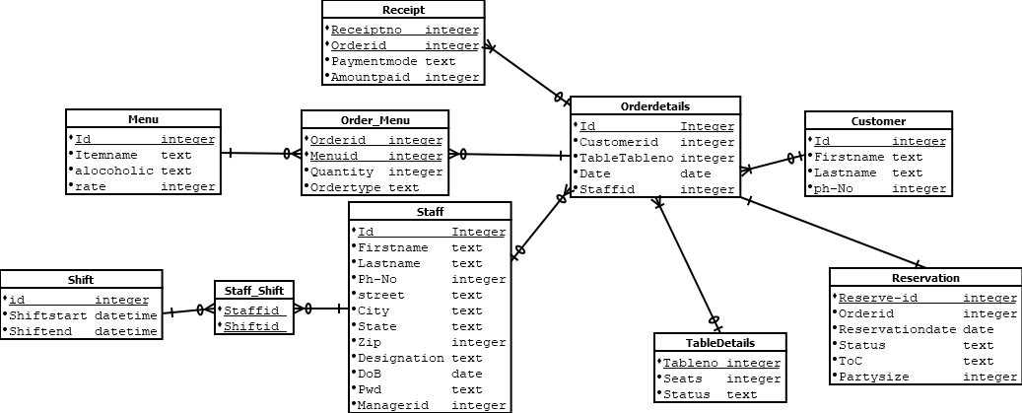

Assumptions and Constraints

Food and Bar orders is a hierarchy is being implemented by the Order table, which has order type attribute to differentiate the orders,

Lastname can be a null value and customer/Staff can choose not to give those details.

Staff can choose to not give their address details then phone number would be primary source of contact

Milestone 4: Normalization and

Milestone 5: Physical Design

Naming Conventions
- Every attributed derived from another table has table name and attribute name together in the receiving table. Ex:- TableTableno
- Every new table created for N-N relationship has both the table names joined with ‘_’ character. Ex:- Order_Menu (resultant of Order and Menu table’s N-N relationship).
Tables

 | Name of the table | Order
 | Description | An order is the request placed by the customer.
 | Attribute | Description |  | Type | Examples of values | Notes
 | Id | Id of the Order |  | Integer | Between 1 and 9999999 | Synthetic Key
 | Customerid | Id of the Customer |  | Integer | Between 1 and 9999999 | Part of natural key
 | TableTableno | Number assigned to the table |  | Integer | Between 1 and  9999999 | A table is always represented by a fixed number
 | Date | Date and time when the order was placed |  | Date | 9/30/2019  00:11:00 | Part of natural key
 | Staffid | Id of the Staff serving |  | Integer | Between 1 and 9999999 | Orders must ne served by the assigned person
 | Functional Dependencies and Keys
 | Functional dependencies | Id → Customerid, TableTableno, Staffid, Date.  (Customerid, Date) → Id, Customerid, TableTableno, Staffid, Date.
 | Candidate keys | Id, (Customerid, Date)
 | Normalization
 | 1NF | Yes | All cells contain a unique value
 | 2NF | Yes | All keys contain a single attribute
 | 3NF | Yes | All non-key attributes depend only on some key
 | BCNF | Yes | All attributes depend only on some key
 | Physical Design
 | Primary Key | Id
 | Foreign Keys | Customerid, TabledetailsTableno, Staffid
 | SQL Code | CREATE TABLE Orderdetails(  Id INTEGER PRIMARY KEY,  Customerid Integer,  TabledetailsTableno Integer,  Orderdate DATE NOT NULL,  Staffid Integer,  FOREIGN KEY (Customerid) REFERENCES CUSTOMER(Id),  FOREIGN KEY (TabledetailsTableno) REFERENCES TABLEDETAILS(Tableno),  FOREIGN KEY (Staffid) REFERENCES STAFF(Id)  );
 | Count of records in the table | 25

 | Name of the table | Customer
 | Description | a Customer is a person who visits the restaurant.
 | Attribute | Description |  | Type | Examples of values | Notes
 | Id | Id of the Customer |  | Integer | Between 1 and 9999999 | Synthetic Key
 | Firstname | First name of the user |  | String with length at least 100 | Venkat | Cannot be null
 | Lastname | Last name of the user |  | String with length at least 100 | Nihaal | Cannot be null
 | Ph-no | Phone number of the customer |  | Integer | 4847251528 | Cannot be null
 | Functional Dependencies and Keys
 | Functional dependencies | Id→ Firstname, Lastname, Ph-no
 | Candidate keys | Id
 | Normalization
 | 1NF | Yes | All cells contain a unique value
 | 2NF | Yes | All keys contain a single attribute
 | 3NF | Yes | All non-key attributes depend only on some key
 | BCNF | Yes | All attributes depend only on some key
 | Physical Design
 | Primary Key | Id
 | Foreign Keys | -
 | SQL Code | CREATE TABLE CUSTOMER(  Id INTEGER PRIMARY KEY,  Firstname varchar2(100) NOT NULL,  Lastname varchar2(100) NOT NULL,  phno integer NOT NULL  );
 | Count of records in the table | 25

 | Name of the table | Staff
 | Description | A staff is a person that works for our restaurant. There are six types of employees: Executive Team, Restaurant Management, Servers, Hosts/Hostesses, Kitchen Staff, Restaurant Management.
 | Attribute | Description |  | Type | Examples of values | Notes
 | Id | Id number of the staff |  | Integer | 56734, 51246 | Synthetic Key
 | Firstname | First name of the user |  | String with length at least 100 | Venkat | Cannot be null
 | Lastname | Last name of the user |  | String with length at least 100 | Nihaal | Cannot be null
 | Ph-no | Phone number of the staff |  | Integer | 4847251528 | Cannot be null
 | Managerid | Id number of the Manager to whom staff reports |  | Integer | 51246, 52789 | Value is taken from the Id column of the staff table for the manager.
 | Designation | Designation of Staff |  | String | Executive Team, Restaurant Management, Servers | Value must be from  Executive Team, Restaurant Management, Servers, Hosts/Hostesses, Kitchen Staff, Restaurant Management
 | DoB | Date of Birth of an employee |  | Date | 1/1/1996 | Must be bigger than 1/1/1900
 | Pwd | Password of the Staff |  | String with length at least 10 | Utr54re366@! (encrypted) | Value must be hashed and stored in database
 | Street | Street name of the staff |  | String | 1086 W king road | Cannot be null
 | City | City name of the staff |  | String | Malvern | Cannot be null
 | State | State name of the staff |  | String | Pennsylvania | Cannot be null
 | Zip | Zip code of the staff |  | Integer | 19355 | Cannot be null
 | Functional Dependencies and Keys
 | Functional dependencies | Id → First Name, Last Name, Managerid, Ph-No, Street, City, State, Zip, Designation, DoB, Pwd.
 | Candidate keys | Id
 | Normalization
 | 1NF | Yes | All cells contain a unique value
 | 2NF | Yes | All keys contain a single attribute
 | 3NF | Yes | All non-key attributes depend only on some key
 | BCNF | Yes | All attributes depend only on some key
 | Physical Design
 | Primary Key | Id
 | Foreign Keys | Managerid
 | SQL Code | CREATE TABLE STAFF(  Id INTEGER PRIMARY KEY,  Firstname varchar2(100) NOT NULL,  Lastname varchar2(100) NOT NULL,  phno integer NOT NULL,  Street varchar2(100) NOT NULL,  City varchar2(50) NOT NULL,  State varchar2(50) NOT NULL,  zip Integer NOT NULL,  Designation varchar2(100) NOT NULL,  DoB Date NOT NULL,  Pwd varchar2(100) NOT NULL,  Managerid Integer,  FOREIGN KEY (Managerid) REFERENCES STAFF(Id)  );
 | Count of records in the table | 31

 | Name of the table | Reservation
 | Description | A Reservation details are stored whenever a customer interacts with the restaurant. There are types of reservation based on customer type: Walkin and Reserved.
 | Attribute | Description |  | Type | Examples of values | Notes
 | Reserve-id | Id of the reservation |  | Integer | 134, 145 | Synthetic Key
 | Reservationdate | Date of the reservation |  | Date | 09/30/2019 | Date after restaurant start
 | Status | Status of the reservation |  | Integer | Available, waiting | Cannot be null
 | ToC | Type of the customer |  | String | Walkin, reserved | Value must be either walkin or reserved
 | Partysize | Number of people accompanied |  | Integer | 10, 30 | Cannot be null
 | Orderid | Id of the Order |  | Integer | Between 1 and 9999999 | Natural Key
 | Functional Dependencies and Keys
 | Functional dependencies | Reserve-id → Reservationdate, Orderid, Status, ToC, Partysize.  Orderid → Reserve-id , Reservationdate, Orderid, Status, ToC, Partysize.
 | Candidate keys | Reserve-id, Orderid
 | Normalization
 | 1NF | Yes | All cells contain a unique value
 | 2NF | Yes | All keys contain a single attribute
 | 3NF | Yes | All non-key attributes depend only on some key
 | BCNF | Yes | All attributes depend only on some key
 | Physical Design
 | Primary Key | Reserve-id
 | Foreign Keys | Orderid
 | SQL Code | CREATE TABLE RESERVATION(  Reserverid Integer PRIMARY KEY,  Orderid Integer,  Reservationdate DATE NOT NULL,  Status Varchar2(15) NOT NULL constraint r_Stat CHECK (Status in ('available','waiting')),  ToC Varchar2(15) NOT NULL constraint r_Toc CHECK (ToC in ('walkin','reserved')),  Partysize Integer NOT NULL,  FOREIGN KEY (Orderid) REFERENCES Orderdetails(Id)  );
 | Count of records in the table | 25

 | Name of the table | Table
 | Description | Table has the details regarding the attributes of a particular table
 | Attribute | Description |  | Type | Examples of values | Notes
 | Tableno | Number assigned to a particular table |  | Integer | 24, 56 | Natural Key
 | Status | Status of the table |  | String | Occupied, Vacant | Cannot be null
 | Seats | Seating capacity of the table |  | Integer | 5, 10 | Cannot be null
 | Functional Dependencies and Keys
 | Functional dependencies | Tableno → Status, Seats.
 | Candidate keys | Tableno
 | Normalization
 | 1NF | Yes | All cells contain a unique value
 | 2NF | Yes | All keys contain a single attribute
 | 3NF | Yes | All non-key attributes depend only on some key
 | BCNF | Yes | All attributes depend only on some key
 | Physical Design
 | Primary Key | Tableno
 | Foreign Keys | -
 | SQL Code | CREATE TABLE TABLEDETAILS(  Tableno Integer PRIMARY KEY,  Seats Integer Not Null,  Status varchar2(20) NOT NULL constraint c_Stat CHECK (Status in ('vacant','occupied'))  );
 | Count of records in the table | 25

 | Name of the table | Receipt
 | Description | A Receipt is the copy of the final bill of the order after the payment is made.
 | Attribute | Description |  | Type | Examples of values | Notes
 | Receiptno | Number on the Receipt |  | Integer | 145, 234 | Weak Attribute
 | Paymentmode | Mode of payment used |  | String | Card, Cash, Coupon | Cannot be null
 | Amountpaid | Value of the amount paid |  | Integer | 1200, 1450 | Cannot be null
 | Orderid | Id of the Order |  | Integer | Between 1 and 9999999 | Receipt depends on this attribute
 | Functional Dependencies and Keys
 | Functional dependencies | Receiptno, Orderid → Paymentmode, Amountpaid.
 | Candidate keys | (Receiptno, Orderid)
 | Normalization
 | 1NF | Yes | All cells contain a unique value
 | 2NF | Yes | All keys contain a single attribute
 | 3NF | Yes | All non-key attributes depend only on some key
 | BCNF | Yes | All attributes depend only on some key
 | Physical Design
 | Primary Key | (Receiptno, Orderid)
 | Foreign Keys | Orderid
 | SQL Code | CREATE TABLE RECEIPT(  Receiptno Integer,  Orderid Integer,  Paymentmode Varchar2(50) NOT NULL,  AmountPaid Integer NOT NULL,  PRIMARY KEY (Receiptno,Orderid),  FOREIGN KEY (Orderid) REFERENCES Orderdetails(Id)  );
 | Count of records in the table | 11

 | Name of the table | Menu
 | Description | A Menu consists of Items that are offered by the restaurant.
 | Attribute | Description |  | Type | Examples of values | Notes
 | Id | Id of the item in the menu |  | Integer | 12, 56 | Synthetic Key
 | Itemname | Name of the item |  | String | Chicken Biryani, Corona | Cannot be null
 | Rate | Price of the item |  | Integer | 25, 50 | Cannot be null
 | Alcohlic | Whether item is alcoholic or not |  | String | Yes, No | Value should only be Yes or No
 | Functional Dependencies and Keys
 | Functional dependencies | Id → Itemname, Rate, Alcoholic.
 | Candidate keys | Id
 | Normalization
 | 1NF | Yes | All cells contain a unique value
 | 2NF | Yes | All keys contain a single attribute
 | 3NF | Yes | All non-key attributes depend only on some key
 | BCNF | Yes | All attributes depend only on some key
 | Physical Design
 | Primary Key | Id
 | Foreign Keys | -
 | SQL Code | CREATE TABLE MENU(  Id Integer PRIMARY KEY,  Itemname Varchar2(20) NOT NULL,  Alcoholic Varchar2(5) NOT NULL constraint m_Alcoholic CHECK (Alcoholic in ('yes','no')),  Rate Integer NOT NULL  );
 | Count of records in the table | 25

 | Name of the table | Order_Menu
 | Description | An Order_Menu Table consists details of the items ordered by the customer. The Order_Menu consists of two types of orders: Food and Bar.
 | Attribute | Description |  | Type | Examples of values | Notes
 | Menuid | Id of the item in the menu |  | Integer | 12, 56 | Part of the candidate key
 | Orderid | Id of the Order |  | Integer | Between 1 and 9999999 | Part of the candidate key
 | Quantity | Quantity of the ordered item |  | Integer | 2, 4 | Cannot be null
 | Ordertype | Whether order is food or bar |  | String | Food/Bar | Cannot be null
 | Functional Dependencies and Keys
 | Functional dependencies | Menuid, Orderid → Quantity,Ordertype.
 | Candidate keys | (Menuid, Orderid)
 | Normalization
 | 1NF | Yes | All cells contain a unique value
 | 2NF | Yes | Every attribute depends on whole key
 | 3NF | Yes | All non-key attributes depend only on some key
 | BCNF | Yes | All attributes depend only on some key
 | Physical Design
 | Primary Key | (Menuid,Orderid)
 | Foreign Keys | Orderid, Menuid
 | SQL Code | CREATE TABLE Order_Menu(  Orderid Integer,  Menuid Integer,  Quantity Integer NOT NULL,  Ordertype Varchar2(5) NOT NULL constraint Om_Ordertype CHECK (Ordertype in ('food','bar')),  PRIMARY KEY(Orderid,Menuid),  FOREIGN KEY (Orderid) REFERENCES Orderdetails(Id),  FOREIGN KEY (Menuid) REFERENCES Menu(Id)  );
 | Count of records in the table | 28

 | Name of the table | Shift
 | Description | Shift table consists the details of when a particular shift start and ends.
 | Attribute | Description |  | Type | Examples of values | Notes
 | Id | Id of the Shift |  | Integer | 1,3 | Synthetic Key
 | Shiftstart | Date & Time when the shift starts |  | Datetime | 2019-09-29 11:00:00 | Cannot be null
 | Shiftend | Date & Time when shift ends |  | Datetime | 2019-09-29 06:00:00 | Cannot be null
 | Functional Dependencies and Keys
 | Functional dependencies | Id → Shiftstart, Shiftend.
 | Candidate keys | Id
 | Normalization
 | 1NF | Yes | All cells contain a unique value
 | 2NF | Yes | All keys contain a single attribute
 | 3NF | Yes | All non-key attributes depend only on some key
 | BCNF | Yes | All attributes depend only on some key
 | Physical Design
 | Primary Key | Id
 | Foreign Keys | -
 | SQL Code | CREATE TABLE Shift(  id Integer PRIMARY KEY,  ShiftStart date NOT NULL,  ShiftEnd date NOT NULL  );
 | Count of records in the table | 30

 | Name of the table | Staff_Shift
 | Description | Staff_Shift table consists the details of which shift did the staff member come in.
 | Attribute | Description |  | Type | Examples of values | Notes
 | ShiftId | Id of the Shift |  | Integer | 1,3 | Part of candidate key
 | Staffid | Id number of the staff |  | Integer | 56734, 51246 | Part of candidate key
 | Functional Dependencies and Keys
 | Functional dependencies | Staffid, Shiftid → Staffid, Shiftid.
 | Candidate keys | (Staffid, Shiftid)
 | Normalization
 | 1NF | Yes | All cells contain a unique value
 | 2NF | Yes | Every attribute depends on whole key
 | 3NF | Yes | All non-key attributes depend only on some key
 | BCNF | Yes | All attributes depend only on some key
 | Physical Design
 | Primary Key | {Staffid,Shiftid)
 | Foreign Keys | Staffid, Shiftid
 | SQL Code | CREATE TABLE STAFF_SHIFT(  Staffid Integer,  Shiftid Integer,  PRIMARY KEY (Staffid,Shiftid),  FOREIGN KEY (Staffid) REFERENCES Staff(Id),  FOREIGN KEY (Shiftid) REFERENCES Shift(id)  );
 | Count of records in the table | 30

Assumptions and Constraints
- Reservation Table is maintained for obtaining customer statistics based on type of customers (Walkin/Reservation).
- There are fixed set of values from which designation of the staff can be chosen.
- The staff is assigned to a order and they server the order based on Table Number.

Milestone 6: SQL queries and

Query 1
English version | Finding a vacant table for the customer at top of waiting queue to sit.
Source for the query need in the SRS document | 9.6 – seat customer from wait queue (a list of available tables to be seated at)
SQL sentence | select tableno, reserverid  from tabledetails, reservation  where tabledetails.seats > reservation.partysize and tabledetails.status= 'vacant'  and  reserverid in (select min(reserverid) from reservation where status = 'waiting');
Example of returned rows (cropped screen caption) | 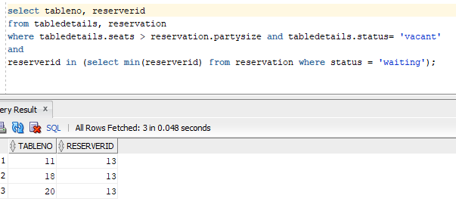

Query 2
English version | Tracking both customer ordered food and bar items
Source for the query need in the SRS document | Track Customer Ordered Items 8.1.20
SQL sentence | select *  from order_menu m,orderdetails o  where o.id= m.orderid and ordertype='food'  union  select *  from order_menu m,orderdetails o  where o.id= m.orderid and ordertype='bar'
Example of returned rows (cropped screen caption) | 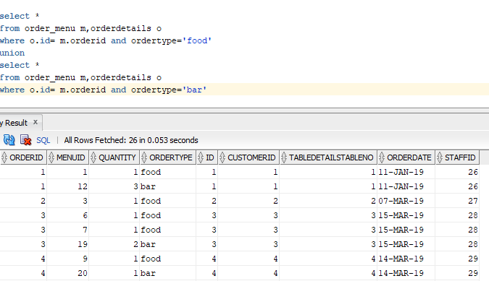

Query 3
English version | Complete details about the customer and his order
Source for the query need in the SRS document | Customer Tracking System - 8.1.22
SQL sentence | select *  from orderdetails o  left join customer on o.customerid=customer.id  order by customerid;
Example of returned rows (cropped screen caption) | 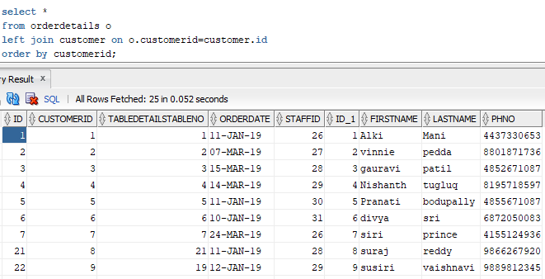

Query 4
English version | Updating a existing reservation after fetching the details through customer phone number.
Source for the query need in the SRS document | 8.1.26 Test Case: Update an existing reservation
SQL sentence | update reservation r  set partysize=8  where  exists  (select o.id  from orderdetails o, customer c w  here o.customerid=c.id and c.phno=8801871736 and r.orderid=o.id);
Example of returned rows (cropped screen caption) | 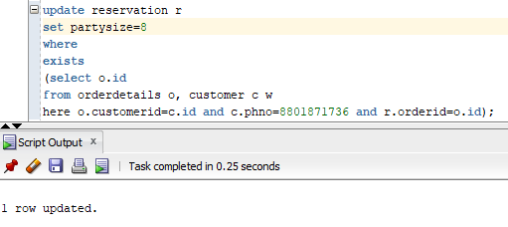

Query 5
English version | To find the count of alcoholic drinks that are being sold for a particular order
Source for the query need in the SRS document | 9.16. Use Case: Drinks Analysis System
SQL sentence | select count(m.ordertype)  from order_menu m  where m.orderid=5  group by m.ordertype  having m.ordertype='bar'
Example of returned rows (cropped screen caption) | 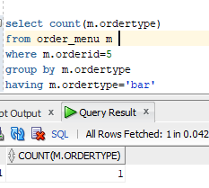

Query 6
English version | Appending an order to the bar tab of the customer by getting his order details through his firstname
Source for the query need in the SRS document | 9.10 Use Case: Append Order to Bar Tab
SQL sentence | insert into order_menu (orderid,menuid,quantity,ordertype)  select distinct(orderid),12,1,'bar'  from order_menu  where orderid in  (select o.id from orderdetails o,customer c where o.id=c.id and c.firstname='Pranati');
Example of returned rows (cropped screen caption) | 